**First Create the Empty folder**

Then create the packge.json file

**npm init –y**

now add the dependencies are

npm install express

Then create the src folder

Then create the simple express js program

let app = require("express")();

app.get("/",(req,res)=> {

    res.send("Simple express module created...")

})

app.listen(9090,()=>console.log("Server is running on port number"))

Then the program using the command as

node src/app.js



Now if you want to run this program using package.json file then we have to do some changes in package.json file provide the app.js file.

"main": "src/app.js",

  "scripts": {

    "start": "node .",

    "test": "echo \"Error: no test specified\" && exit 1"

  }

Now you can run the command as

npm run start

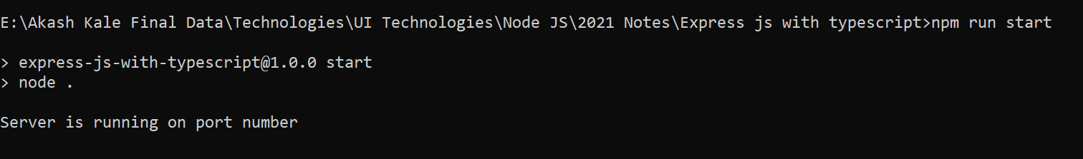

Now open the tsconfig.json file and give the output directory name

"outDir": "dist",

And do the change in package.json file as

 "main": "dist/app.js",

Then run the program then may be you will get the error

Using the command as tsc

So now you have to do the change the programs.

import express,{Request,Response} from 'express'

let app = express();

app.get("/",(req:Request,res:Response)=> {

    res.send("Simple express module created...")

})

app.listen(9090,()=>console.log("Server is running on port number"))

now add the typescript dependencies

npm install typescript –save-dev

npm install ts-node –save-dev

npm install @types/node –save-dev

npm install @types/express –save-dev

now we have to create the tsconfig.json file

tsc –init